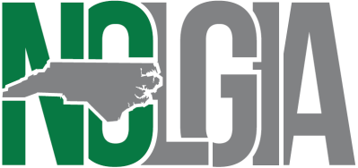**2024 SUMMER CONFERENCE**

**July 24-25, 2024**

**Wilmington, NC**

**BUSINESS MEETING AGENDA**

Recognition of Summer Conference sponsors:

* **Premium Sponsor** – North Carolina Capital Management Trust
* **Platinum Sponsors** – Chandler Asset Management, North Carolina CLASS
* **Gold Sponsor** – JP Morgan-Chase, North Carolina Investment Pool, Civic Federal Credit Union, Multi-Bank Securities, Inc., Huntington Bank, First National Bank
* **Silver Sponsors** – UBS Financial Services, Davenport, Wells Fargo
* **Bronze Sponsors** – three+one, Valley View Consulting, McGuire Woods

Dismiss Vendors and non-members*

Call to Order

Recognition of Past Presidents

Recognition of First Time Attendees

President’s Report

Treasurer’s Report

* Review and approval of financial report

Secretary’s Report

* Review and approval of 2024 Winter Conference business meeting minutes

New Business – President

* Approval New Board Member Melissa Moore, Buncombe County, Membership Coordinator
* Board’s Strategic Visioning for enhancing membership value
* Dates for 2025 Winter Conference – February 18-20, 2025 in Pinehurst, NC – subsequent to NCGFOA at Pinehurst.
* Dates for 2025 Summer Conference- July 23-24, 2025 in Wilmington, NC

Other Business - President

* Conference presentations posted on the Association website – [www.nclgia.org](http://www.nclgia.org)
* Don’t forget to take advantage of the NCLGIA listserv – [nclgia@listserv.unc.edu](mailto:nclgia@listserv.unc.edu)
* Conference evaluation forms
* CPE sign in sheet and CPE credit forms
* Reminder: NCCMT Reception 5:30 Cloud 9 Rooftop Bar

Adjourn for Lunch

*\* Vendors are asked to please excuse themselves from the business meeting.*